# ELEC5570M Control Systems Design COURSEWORK

STUDENT ID: 201388759

NAME: ZHU ZHU

CATOLOG

ELEC5570M Control Systems Design COURSEWORK 1

PART A: ROOT LOCUS 2

TASK 1: 2

1.1) 2

1.2) 2

DESIGN OF A PD CONTROLLER 6

TASK 2 6

2.1) 6

2.2) 7

DESIGN OF A PID CONTROLLER 10

TASK 3 10

3.1) 10

3.2) 12

TASK 4 12

4.1) 12

4.2) 13

PART B: FREQUENCY RESPONSE 14

TASK 5 14

5.1) 14

5.2) 15

5.3) 15

DESIGN OF A LEAD COMPENSATOR FOR K(s) 16

TASK 6 16

6.1) 16

6.2) 16

6.3) 17

6.4) 17

DESIGN OF A LEAD-LAG COMPENSATOR FOR K(s) 19

TASK 7 19

7.1) 19

7.2) 20

7.3) 23

## PART A: ROOT LOCUS

#### TASK 1:

##### 1.1)

Figure 1.1.1 The code of task 1

Figure 1.1.2 The root locus plot

##### 1.2)

The second order approximation of the third order system is:

$$G_{approx.}\left(s\right)= \frac{β_{2}s+ α_{2}β_{1}}{s^{2}+α_{2}s+α_{2}α_{1}}$$

And the close system transform function is:

$$G= \frac{s+2}{s^{3}+6s^{2}+13.5s+39.5}$$

Therefore,

$$α_{1}=\frac{39.5}{13.5}=2.9259$$

$$a_{2}=\frac{{13.5}^{2}}{6×13.5-39.5×1}=4.3916$$

$$β_{1}=\frac{2}{12.5}=0.1481$$

$$β_{2}=\frac{1×12.5}{12.5×6-37.5×1}=0.3253$$

Therefore,

$$G_{approx.}\left(s\right)= \frac{0.3253s+ 4.3916×0.1481}{s^{2}+4.3916s+2.9259×4.3916}=\frac{0.3253s+ 0.65}{s^{2}+4.3916s+12.849}$$

After that, open loop the function and plot its root locus.

The following is the code used in MATLAB for this approximated second-order system.

Figure 1.2.1 The root locus plot of approximates second order system.

The settling time $T_{s}$ is given by:

$$T_{s}= \frac{4}{ζω_{n}}$$

Where $ζ$ is the damping ratio and $ω_{n}$ is the natural frequency of the system.

Based on the data provided in Figure 1.1.1, the damping ratio is 1, the frequency is 4.86 and the gain is 17.2. Therefore,

$$T_{s}= \frac{4}{4.86}= 0.8264s$$

Verify the step response of the closed-loop system of .

The settling time derived from the approximated second-order system is 0.8264 seconds, whereas the step response graph of the third-order system shows a settling time of 3 seconds(within 2% of the final value, which is 0.465), which can be attributed to the simplification inherent in the approximation. A second-order approximation neglects the dynamics contributed by the third pole, which can lead to a faster predicted settling time. The root locus provides a simplified view, focusing on dominant poles that most significantly affect the system's transient response. However, in the actual third-order system, all poles contribute to the dynamics, which often results in a slower response and a longer settling time.

### DESIGN OF A PD CONTROLLER

#### TASK 2

$K(s) = k(s + z1 ).$ $$G(s) = \frac{s+2 }{(s^{2}+s+7.5)(s+5) }$$

##### 2.1)

Analysis of this function reveals the following characteristics:

Zeroes: The system has a single zero located at s=−2. Additionally, the system incorporates an added zero at s = -z1 through the implementation of the PD controller.

Poles: The system exhibits three poles. Two of these poles are complex conjugates, located at s=−0.5±2.693i, and the third pole is a real number at s=−5.

The following figure illustrates the connections from the desired point to each pole and zero of the control system in the complex plane. The zero $θ_{5}$ is identified as the zero-point z1 introduced by the PD controller. Blue lines represent connections to zeroes, and black lines represent connections to poles.

Angle condition:

The angle subtended by the line from the desired point to a pole, reduced by the angle to a zero, equals 180 degrees.

$$∠θ_{1}+θ_{2}+θ_{3}-θ_{4}-θ_{5}=180°$$

And

|  |  |  |  |
| --- | --- | --- | --- |
| $$θ_{1}$$ | $$θ_{2}$$ | $$θ_{3}$$ | $$θ_{4}$$ |
| $$152.857°$$ | $$120.325°$$ | $$90°$$ | $$120.964°$$ |

Therefore,

$$θ_{5}=62.22°$$

$$\tan_{θ_{5}}=1.898=\frac{5}{z1-5}$$

From this relationship, z1 is deduced to be 7.634.

##### 2.2)

Magnitude condition:

$$\left|G\left(s\right)K\left(s\right)\right|=1$$

Substitute s=(-5+5i) to:

$$\left|G\left(s\right)K\left(s\right)\right|=\frac{ k(s + z1 )(s+2) }{(s^{2}+s+7.5)(s+5) }=1$$

Therefore, it is computed that the gain k equals 6.8385.

2.3)

Below is the root locus plot drawn by the code in MATLAB.

The root locus plot indicates that the desired point lies on the trajectory, meeting the specified requirements. Additionally, it is observed that the gain k is 6.83, which is consistent with the value of k determined in section 2.2). The damping ratio is 0.707, and the frequency is 7.06.

The settling time $T_{s}$ is given by:

$$T_{s}= \frac{4}{ζω_{n}}$$

Therefore,

$$T_{s}= \frac{4}{0.707 ×7.06}= 0.8014s$$

Verify the step response of the closed-loop system.

Below is the step plot drawn by the code in MATLAB.

rom this, it can be concluded that the settling time (within 2% of the final value, which is 0.728) is 0.93 seconds, which is similar to the previous estimates value 0.8014 seconds.

### DESIGN OF A PID CONTROLLER

#### TASK 3

$$K\left(s\right) = \frac{ k(s + z1 )(s+2)}{s}$$

$$G(s) = \frac{s+2 }{(s^{2}+s+7.5)(s+5) }$$

##### 3.1)

Analysis of this function reveals the following characteristics:

Zeroes: The system has a single zero located at s=−2. Additionally, the system incorporates two added zeroes at s = -z1 and s= -2 through the implementation of the PID controller.

Poles: The system exhibits three poles. Two of these poles are complex conjugates, located at s=−0.5±2.693i, and the third pole is a real number at s=−5. Additionally, the system incorporates a single pole at s = 0 through the implementation of the PID controller.

The following figure illustrates the connections from the desired point to each pole and zero of the control system in the complex plane.

Angle condition:

The angle subtended by the line from the desired point to a pole, reduced by the angle to a zero, equals 180 degrees.

$$∠θ_{1}+θ_{2}+θ_{3}-θ_{4}-θ_{5}-θ_{6}+θ_{7}=180°$$

And

|  |  |
| --- | --- |
| $$θ_{6}$$ | $$θ_{7}$$ |
| $$125.964°$$ | $$135°$$ |

Therefore,

$$θ_{5}=76.254$$

$$\tan_{θ_{5}}=4.088=\frac{5}{z1-5}$$

From this relationship, z1 is deduced to be 6.223.

Magnitude condition:

$$\left|G\left(s\right)K\left(s\right)\right|=1$$

Substitute s=(-5+5i) to:

$$\left|G\left(s\right)K\left(s\right)\right|=\frac{ k(s + z1 )(s+2)(s+2) }{s(s^{2}+s+7.5)(s+5) }=1$$

Therefore, it is computed that the gain k equals 9.1048.

##### 3.2)

Below is the root locus plot drawn by the code in MATLAB.

The root locus plot indicates that the desired point lies on the trajectory, meeting the specified requirements. Additionally, it is observed that the gain k is 9.1, which is similar to the previous estimates value 9.1048. The damping ratio is 0.707, and the frequency is 7.06.

The settling time $T_{s}$ is given by:

$$T_{s}= \frac{4}{ζω_{n}}$$

Therefore,

$$T_{s}= \frac{4}{0.707 ×7.06}= 0.8014s$$

Verify the step response of the closed-loop system.

Below is the step plot drawn by the code in MATLAB.

According to this, it can be concluded that the settling time (within 2% of the final value, which is 1) is 2.25s, which is much larger than the predicted value of 0.8014s.

The reason for large error of predicated value is that the PID controller introduces new poles which can cause additional delays or oscillations, thereby increasing the actual settling time and leading to inaccuracies in predictions.

#### TASK 4

##### 4.1)

In the root locus diagram, the dominant poles of the PD controller are closer to the imaginary axis, which leads to a faster transient response of the system. In contrast, the dominant poles of the PID controller are further from the imaginary axis, resulting in higher stability and a slower transient response. The position of the dominant poles directly affects the system's transient characteristics, including overshoot and settling time.

The purpose of the root locus plot is to show how the closed-loop poles move with changes in gain, but its estimates of overshoot and settling time are typically based on the system's dominant poles and assume that the influence of other poles is minor. The PID controller introduces new poles that can cause additional delays or oscillations, thereby increasing the actual settling time and leading to inaccuracies in predictions.

According to the step response graph, the PD controller exhibits a faster rise time but also a greater overshoot. Therefore, the PD controller can respond quickly to changes but may have lower stability. In contrast, the PID controller has a smaller overshoot and a longer settling time, indicating a better balance between transient and steady-state performance.

So, it more suitable for use PID controller.

##### 4.2)

According to my student ID, I chose 13.88759 as the gain.

According to the root locus plot, compared with the scalar controller, the dominant poles for PD and PID controllers are closer to the imaginary axis, meaning that they have a quicker transient response. The poles for the scalar controller are further from the imaginary axis, potentially resulting in a slower system response.

According to the step response graph, the PD controller has the shortest response time but the largest overshoot. Although the overshoot of the PID controller is small, its response speed is average which is between PD and scalar controllers. Scalar controllers have the slowest response and relatively large overshoot. Overall, the scalar controller is worse than the PD and PID controller in terms of transient performance.

## PART B: FREQUENCY RESPONSE

#### TASK 5

##### 5.1)

The following is the code to produce bode diagram.

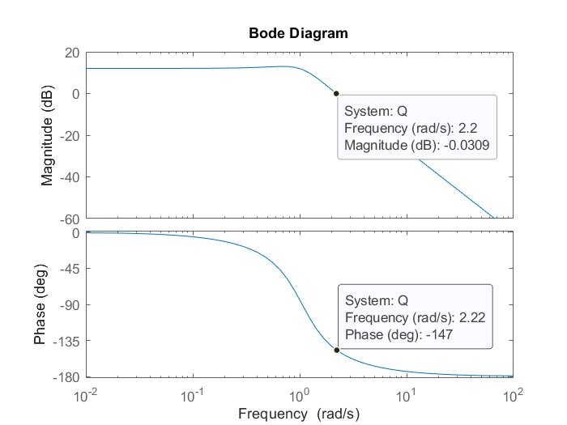

According to this bode diagrams, the phase margin PM is 32° and crossover frequency 𝜔𝑜 is 2.22 rad/s.

##### 5.2)

$$G\left(s\right)= \frac{4}{{0.9s}^{2}+s+5 } , K\left(s\right)=1 and H\left(s\right)=1.$$

$$W(s)= \frac{4}{{0.9s}^{2}+s+5 }$$

Rewrite $W(s)= \frac{4}{{0.9s}^{2}+s+2 }$ as $W(s) = \frac{{ω_{n}}^{2}}{s^{2}+2ζω_{n}s+{ω_{n}}^{2} }$:

$$W\left(s\right)=0.8 \frac{5.556}{s^{2}+1.111s+5.556 }$$

Therefore,

$$ω_{n}=\sqrt{5.556}=2.357$$

$$ζ=\frac{1.11}{2\sqrt{5.556}}=0.2357$$

##### 5.3)

The closed-loop bandwidth (≈𝜔𝑛=2.357) is approximately equal to the crossover frequency (𝜔0=2.22), and the phase margin (in degrees) is 32° which is approximately equal to the closed-loop damping ratio, 23.57.

### DESIGN OF A LEAD COMPENSATOR FOR K(s)

#### TASK 6

##### 6.1)

The following is the bode diagram at 6.13 rad/s.

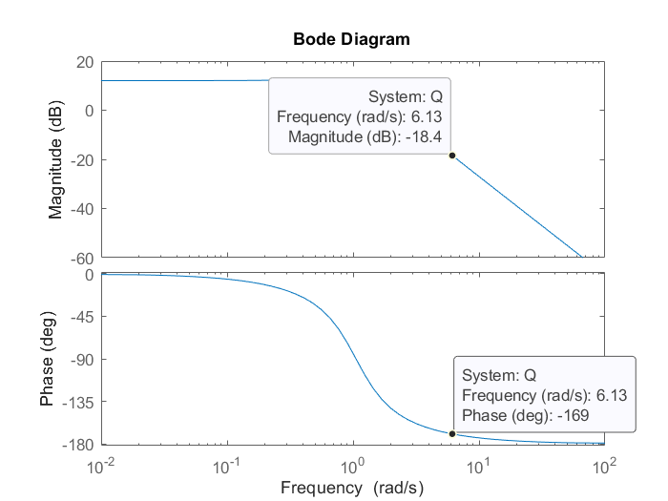

##### 6.2)

According to the bode diagram, the phase of the system is -169° and magnitude is -18.4 at $ω=6.13 rad/s$ *.*

According to $20\log{gain}=gain in dB$

Gain ${10}^{\frac{18.4}{20}}=- 8.3176$

##### 6.3)

Additional phase required is PM-(180 +phase) = 55-(180-169)=44°, which is $ϕ_{m}$.

$$α=\frac{1+\sin{ϕ_{m}}}{1+\sin{ϕ_{m}}}=5.55$$

$$τ=\frac{1}{ω_{max}\sqrt{α}}=\frac{1}{6.13\sqrt{5.55}}0.0692 s$$

$\left|K\left(jω_{max}\right)\right|=k\sqrt{α}=k\sqrt{5.55}=8.3176$, thus $k=3.531$

Therefore,

##### 6.4)

And the following is the bode diagrams.

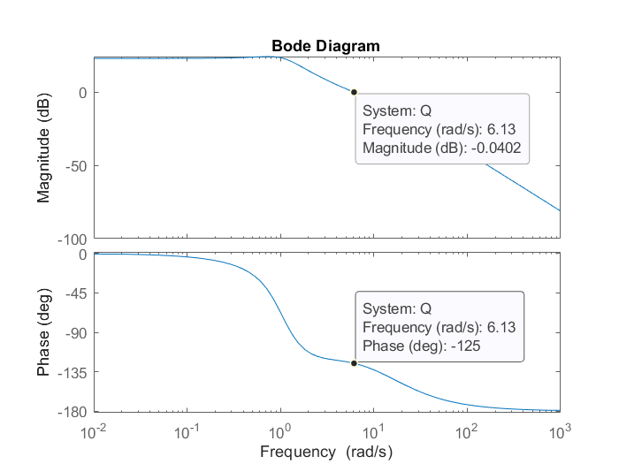

The phase margin is 55° and magnitude is approximately 0 at 6.13 rad/s.

The following is the step response diagram.

The rise time is the duration it takes for the response to increase from 10% (0.0934) to 90% (0.84) of the final value.

$$T_{r}=0.238-0.0516=0.1864s$$

The settling time (within 2% of final value, 0.951): $T_{s}=1.02 s$

Overshoot is calculated as the percentage difference between the response's peak value and its steady-state value.

$$overshoot=\frac{peak value-steady state value}{steady state value} ×100\%=\frac{1.5-0.934}{0.934}×100\%=23.126\%$$

### DESIGN OF A LEAD-LAG COMPENSATOR FOR K(s)

#### TASK 7

##### 7.1)

$$ess\lim_{s→0}{sE\left(s\right)}=\lim_{s→0}{sE\left(s\right)}=\lim_{s→0}{s\frac{1/s}{1+G\left(s\right)K(s)}}=\lim_{s→0}{\frac{1}{1+\frac{4}{0.9s^{2}+s+1}K(s)}}=\lim_{s→0}{s\frac{{0.9}^{2}}{{0.9}^{2}+s+1+4K(s)}}=\frac{1}{1+4K(0)}<0.01$$

So,

$$K(0)>24.75$$

We will choose $K\left(0\right)=24.75.$

Since $K\left(s\right)=Kleag\left(s\right) Klag(s)$,

So $K\left(0\right)=Kleag\left(0\right) Klag\left(0\right)=3.531 Klag(0)$

Therefore,

$$Klag\left(0\right)=7.009$$

$$α_{1}=\frac{1}{Klag\left(0\right)}=0.143$$

$$ω1=\frac{ω0}{10}=0.613$$

$$τ=\frac{1}{ω1\sqrt{α1}}=\frac{1}{0.613\sqrt{0.143}}=4.3139$$

Therefore,

##### 7.2)

Compare the effects of phase lead and lead-lag compensators:

The Bode plot shows that the effects of compensators on system gain and phase. The phase lead compensator enhances the phase margin, which contributes to improved stability and the ability to tolerate large variations in gain without becoming unstable. Additionally, the compensator affects the amplitude-frequency characteristics, it is possible to increase or decrease the resonance peak, and directly change the system's response speed and overshoot to input changes.

The lead-lag compensator not only increases phase margin but also adjusts the frequency. This means the system can sustain a huge range of gain variations within a given frequency range while remaining stable.

According to the diagram of the step response, the phase lead compensator shortens the rise time and reduces the overshoot. Meanwhile, the lead-lag compensator further reduces overshoot and improves the steady-state error of the system.

##### 7.3)

图表

In the provided Bode plots comparing different controllers, the phase lead compensator significantly increases the phase margin over the scalar controller, indicating an improvement in stability margins. This is critical for systems where phase stability is a concern. The phase lead compensator achieves this by introducing a zero that advances the phase in the critical frequency range where the gain crossover occurs.

The lead-lag compensator, while also improving phase margin, additionally flattens the gain curve around the crossover frequency. This is indicative of a wider bandwidth, which translates to a faster system response to changes in input. Both compensators show a higher phase margin compared to the scalar controller, suggesting better resistance to phase-related instabilities.图表, 折线图, 直方图

The step response corroborates the frequency domain analysis. The scalar controller's step response exhibits more overshoot and a slower settling time, attributed to the lack of phase compensation. In contrast, the phase lead compensator demonstrates a quicker rise time and reduced overshoot, indicative of an improved transient response. The lead-lag compensator shows an even better transient response with minimal overshoot and faster settling, suggesting a balanced approach in both phase and gain adjustments, which optimizes both transient and frequency responses.

These observations imply that for control systems requiring precise and stable behavior, a well-designed phase lead or lead-lag compensator is more suitable than a simple scalar gain adjustment.